**MACHINE LEARNING ASSIGNMENT 6**

**Preetham Kesireddy**

**ID: 700741299**

**Github Link:** [**https://github.com/700741299-Preetham/Machine-Learning/tree/main/Assignment%206**](https://github.com/700741299-Preetham/Machine-Learning/tree/main/Assignment%206)

**Video Link:** [**https://youtu.be/shhDtqMAxno**](https://youtu.be/shhDtqMAxno)

**Question 1**

Single Link Proximity:

* In **Single Linkage,**the distance between two clusters is the minimum distance between members of the two clusters

|  |  |  |  |  |  |  |  |  |  |  |  |
| --- | --- | --- | --- | --- | --- | --- | --- | --- | --- | --- | --- |
|  | | **p1** | | **p2** | | **p3** | | **p4** | | **p5** | **p6** |
| **p1** | | 0 | | 0.2357 | | 0.2218 | | 0.3688 | | 0.3421 | 0.2347 |
| **p2** | | 0.2357 | | 0 | | 0.1483 | | 0.2042 | | 0.1388 | 0.254 |
| **p3** | | 0.2218 | | 0.1483 | | 0 | | 0.1513 | | 0.2843 | 0.11 |
| **p4** | | 0.3688 | | 0.2042 | | 0.1513 | | 0 | | 0.2932 | 0.2216 |
| **p5** | | 0.3421 | | 0.1388 | | 0.2843 | | 0.2932 | | 0 | 0.3921 |
| **p6** | | 0.2347 | | 0.254 | | 0.11 | | 0.2216 | | 0.3921 | 0 |
|  | |  | |  | |  | |  | |  |  |
| smallest distance is | | | | | | | | | | 0.11 |  |
| so p3 and p6 forms first cluster | | | | | | | | | | |
|  | **p1** | | **p2** | | **p36** | | **p4** | | **p5** | |
| **p1** | 0 | | 0.2357 | | 0.2218 | | 0.3688 | | 0.3421 | |
| **p2** | 0.2357 | | 0 | | 0.1483 | | 0.2042 | | 0.1388 | |
| **p36** | 0.2218 | | 0.1483 | | 0 | | 0.1513 | | 0.2843 | |
| **p4** | 0.3688 | | 0.2042 | | 0.1513 | | 0 | | 0.2932 | |
| **p5** | 0.3421 | | 0.1388 | | 0.2843 | | 0.2932 | | 0 | |
|  |  | |  | |  | |  | |  | |
| smallest distance is | | | | | | | | | 0.1388 | |

|  |  |  |  |  |  |
| --- | --- | --- | --- | --- | --- |
| so p2 and p5 forms 2nd cluster | | | | | |
|  | **p1** | **p25** | **p36** | **p4** |  |
| **p1** | 0 | 0.2357 | 0.2218 | 0.3688 |  |
| **p25** | 0.2357 | 0 | 0.1483 | 0.2042 |  |
| **p36** | 0.2218 | 0.1483 | 0 | 0.1513 |  |
| **p4** | 0.3688 | 0.2042 | 0.1513 | 0 |  |
|  |  |  |  |  |  |
| smallest distance is | | | | | 0.1483 |
| so p25 and p36 forms 3rdcluster | | | | | |
|  |  |  |  |  |  |
|  | **p1** | **p(25)(36)** | **p4** |  |  |
| **p1** | 0 | 0.2218 | 0.3688 |  |  |
| **p(25)(36)** | 0.2218 | 0 | 0.1513 |  |  |
| **p4** | 0.3688 | 0.1513 | 0 |  |  |
|  |  |  |  |  |  |
| smallest distance is | | | | | 0.153 |
| so p(25)(36)and p4 forms 4thcluster | | | | | |
|  | **p1** | **p4(25)(36)** |  |  |  |
| **p1** | 0 | 0.2218 |  |  |  |
| **p4(25)(36)** | 0.2218 | 0 |  |  |  |

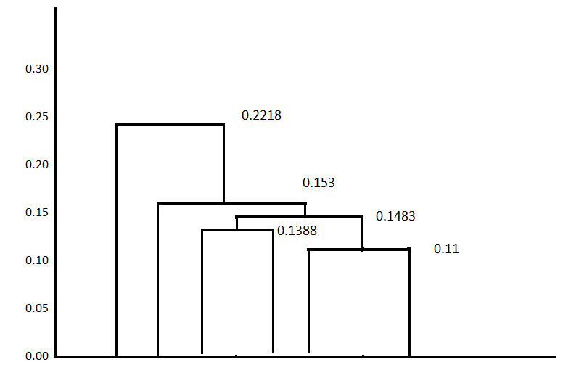

**1 4 2 5 3 6**

Complete Link Proximity:

* In **Complete Linkage,**the distance between two clusters is the maximum distance between members of the two clusters

|  |  |  |  |  |  |  |
| --- | --- | --- | --- | --- | --- | --- |
|  | **p1** | **p2** | **p3** | **p4** | **p5** | **p6** |
| **p1** | 0 | 0.2357 | 0.2218 | 0.3688 | 0.3421 | 0.2347 |
|  |  |  |  |  |  |  |
|  |  |  |  |  |  |  |
| **p2** | 0.2357 | 0 | 0.1483 | 0.2042 | 0.1388 | 0.254 |
| **p3** | 0.2218 | 0.1483 | 0 | 0.1513 | 0.2843 | 0.11 |
| **p4** | 0.3688 | 0.2042 | 0.1513 | 0 | 0.2932 | 0.2216 |
| **p5** | 0.3421 | 0.1388 | 0.2843 | 0.2932 | 0 | 0.3921 |
| **p6** | 0.2347 | 0.254 | 0.11 | 0.2216 | 0.3921 | 0 |
|  |  |  |  |  |  |  |
| smallest distance is | | | | | 0.11 |  |
| so p3 and p6 forms first cluster | | | | | |  |
|  | **p1** | **p2** | **p36** | **p4** | **p5** |  |
| **p1** | 0 | 0.2357 | 0.2347 | 0.3688 | 0.3421 |  |
| **p2** | 0.2357 | 0 | 0.254 | 0.2042 | 0.1388 |  |
| **p36** | 0.2347 | 0.254 | 0 | 0.2216 | 0.3921 |  |
| **p4** | 0.3688 | 0.2042 | 0.2216 | 0 | 0.2932 |  |
| **p5** | 0.3421 | 0.1388 | 0.3921 | 0.2932 | 0 |  |
|  |  |  |  |  |  |  |
| smallest distance is | | | | | 0.1388 |  |
| so p2 and p5 forms 2nd cluster | | | | | |  |
|  | **p1** | **p25** | **p36** | **p4** |  |  |
| **p1** | 0 | 0.3421 | 0.2347 | 0.3688 |  |  |
| **p25** | 0.3421 | 0 | 0.3921 | 0.2932 |  |  |
| **p36** | 0.2347 | 0.3921 | 0 | 0.2216 |  |  |
| **p4** | 0.3688 | 0.2932 | 0.2216 | 0 |  |  |
|  |  |  |  |  |  |  |
| smallest distance is | | | | | 0.2216 |  |
| so p25 and p36 forms 3rdcluster | | | | | |  |
|  | **p1** | **p(25)(36)** | **p4** |  |  |  |
| **p1** | 0 | 0.3421 | 0.3688 |  |  |  |
| **p(25)(36)** | 0.3421 | 0 | 0.2932 |  |  |  |
| **p4** | 0.3688 | 0.2932 | 0 |  |  |  |
|  |  |  |  |  |  |  |
| smallest distance is | | | | | 0.2932 |  |
| so p(25)(36)and p1 forms 4thcluster | | | | | |  |
|  | **p1(25)(36)** | **p4** |  |  |  |  |
| **p1(25)(36)** | 0 | 0.1483 |  |  |  |  |
| **p4** | 0.3688 | 0 |  |  |  |  |

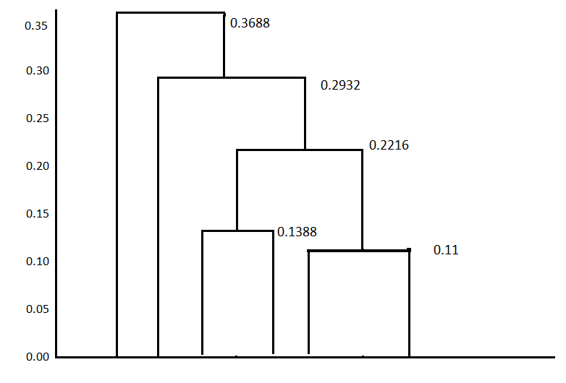

**4 1 2 5 3 6**

Average Link Proximity:

* In **Average Linkage,**the distance between two clusters is the average of all distances between members of the two clusters

|  |  |  |  |  |  |  |
| --- | --- | --- | --- | --- | --- | --- |
|  | **p1** | **p2** | **p3** | **p4** | **p5** | **p6** |
| **p1** | 0 | 0.2357 | 0.2218 | 0.3688 | 0.3421 | 0.2347 |
| **p2** | 0.2357 | 0 | 0.1483 | 0.2042 | 0.1388 | 0.254 |
| **p3** | 0.2218 | 0.1483 | 0 | 0.1513 | 0.2843 | 0.11 |
| **p4** | 0.3688 | 0.2042 | 0.1513 | 0 | 0.2932 | 0.2216 |
| **p5** | 0.3421 | 0.1388 | 0.2843 | 0.2932 | 0 | 0.3921 |
| **p6** | 0.2347 | 0.254 | 0.11 | 0.2216 | 0.3921 | 0 |
|  |  |  |  |  |  |  |
| smallest distance is | | | | | 0.11 |  |
| so p3 and p6 forms first cluster | | | | | |  |
|  | **p1** | **p2** | **p36** | **p4** | **p5** |  |
| **p1** | 0 | 0.2357 | 0.22825 | 0.3688 | 0.3421 |  |
| **p2** | 0.2357 | 0 | 0.20115 | 0.2042 | 0.1388 |  |
| **p36** | 0.22825 | 0.20115 | 0 | 0.18645 | 0.3382 |  |
| **p4** | 0.3688 | 0.2042 | 0.18645 | 0 | 0.2932 |  |
| **p5** | 0.3421 | 0.1388 | 0.3382 | 0.2932 | 0 |  |
|  |  |  |  |  |  |  |
| smallest distance is | | | | | 0.1388 |  |
| so p2 and p5 forms 2nd cluster | | | | | |  |
|  | **p1** | **p25** | **p36** | **p4** |  |  |
| **p1** | 0 | 0.2889 | 0.2347 | 0.3688 |  |  |
| **p25** | 0.2889 | 0 | 0.269675 | 0.2487 |  |  |
| **p36** | 0.2347 | 0.269675 | 0 | 0.18645 |  |  |
| **p4** | 0.3688 | 0.2487 | 0.18645 | 0 |  |  |
|  |  |  |  |  |  |  |
| smallest distance is | | | | | 0.18645 |  |
| so p25 and p36 forms 3rdcluster | | | | | |  |
|  | **p1** | **p(25)(36)** | **p4** |  |  |  |
| **p1** | 0 | 0.2618 | 0.3688 |  |  |  |
| **p(25)(36)** | 0.2618 | 0 | 0.217575 |  |  |  |
| **p4** | 0.3688 | 0.217575 | 0 |  |  |  |
|  |  |  |  |  |  |  |
| smallest distance is | | | | | 0.217575 |  |
| so p(25)(36)and p1 forms 4thcluster | | | | | |  |
|  | **p1(25)(36)** | **p4** |  |  |  |  |
| **p1(25)(36)** | 0 | 0.3153 |  |  |  |  |
| **p4** | 0.3153 | 0 |  |  |  |  |

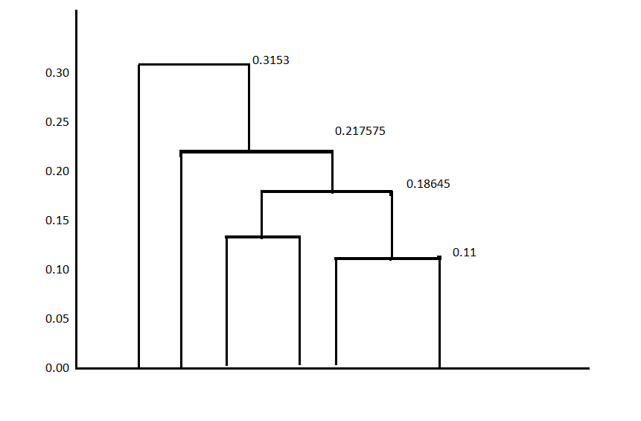

**4 1 2 5 3 6**

Question 2

2.a

2.b

2.c

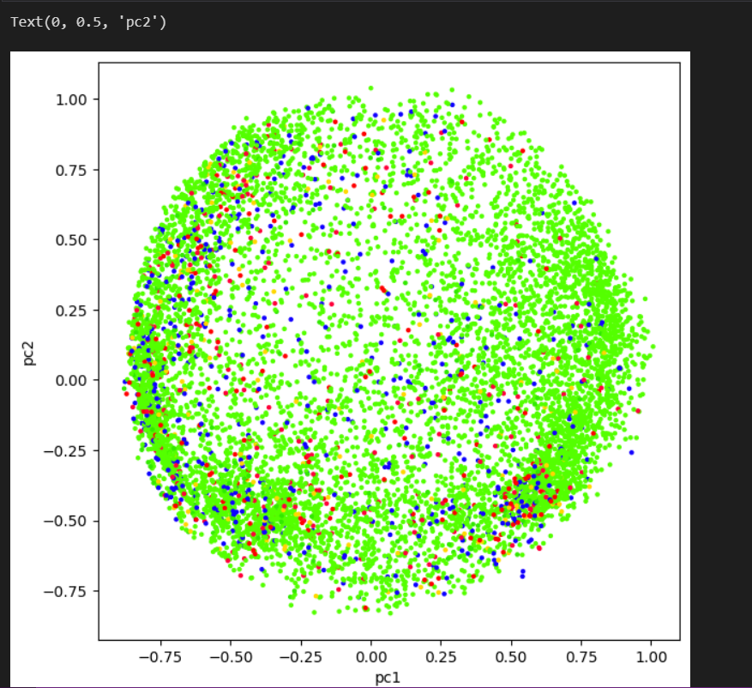

2.d For K = 2

For K = 3

For K = 4

For K = 5

2.e. Bar Chart:

